63BITS MVC Project Structure Todo

This exercise demonstrates the full implementation of an MVC page based on a Products example. It implements two pages:
- Products Listing Page – Displays a list of all products stored in the database.
- Product Detail Page – Shows detailed information for a specific product.

Model
Navigate to SixtyThreeBits.Web → Models → Website and create a new directory named Products. This directory organizes all product-related models in one location.
Inside the Products directory, create a new file named ProductsWebsiteModel.cs.

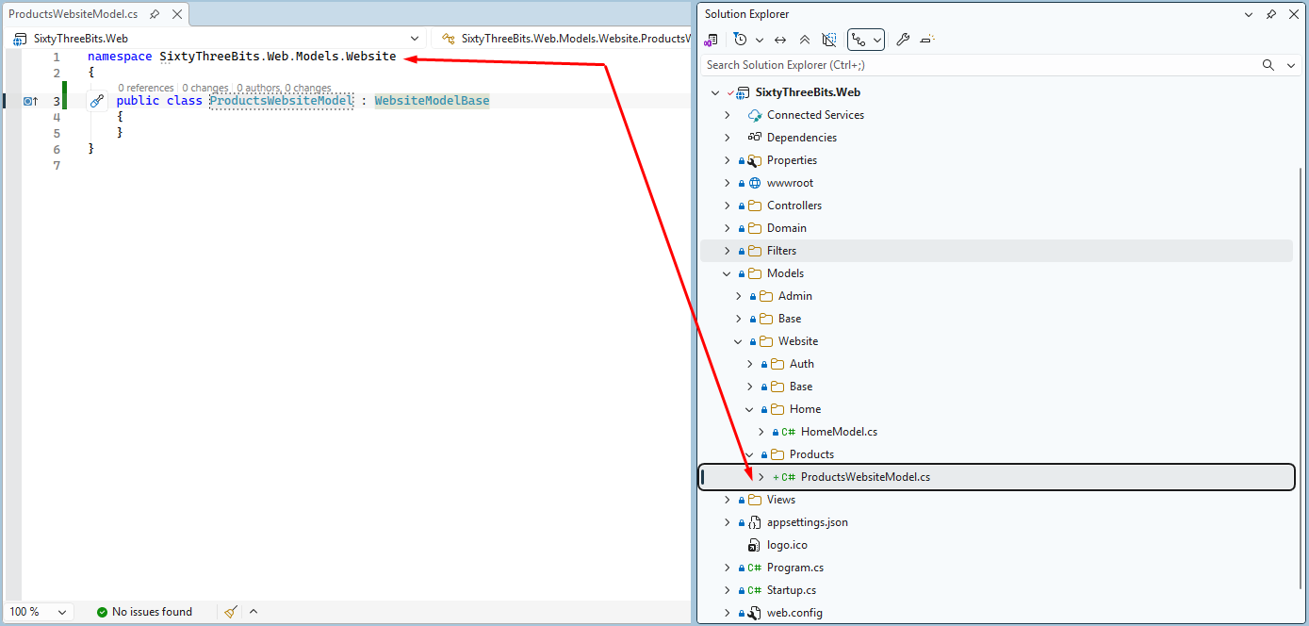

Note that the class name ProductsWebsiteModel uses the plural form, indicating that this model is responsible for handling and presenting multiple products.

ViewModel

To determine which properties are required in the ViewModel, we must first visualize the structure. In this example, we are creating a page that displays a list of products. The page should include a title and products as individual cards or boxes, each product card must have information such as name, image, price, and a link to the product details page.
From this concept, we can identify three primary page components:
- Page Title component
- Product List component
- Product List Item component, containing the following fields:
  - Product Name
  - Product Cover Image
  - Product Price
  - URL to the product detail page
To support this structure visually, look at the sample image below:

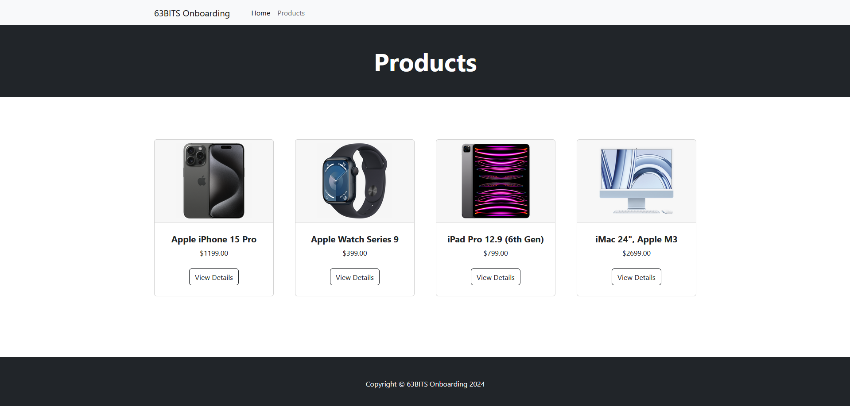

Implement code according to screenshot below
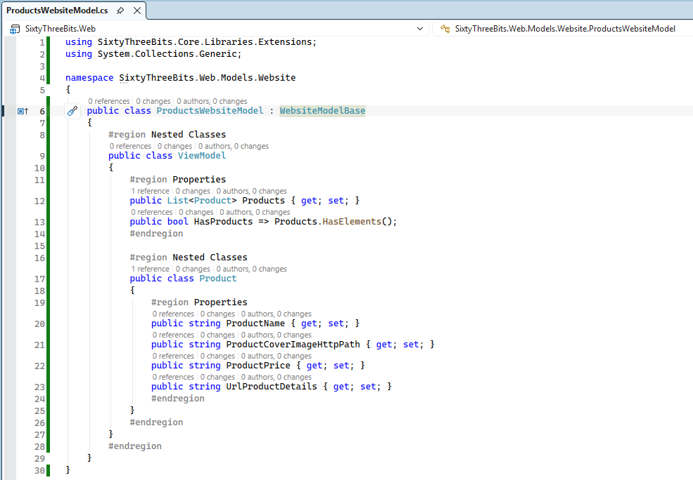

Examine the structure of the ProductsWebsiteModel class. It contains a nested ViewModel class, which itself contains a nested Product class. This two-level nesting structure represents the page data (ViewModel) and individual items within the product list (Product).
Create second level nested classes only when necessary to represent distinct data structures.

The ViewModel class defines two properties:
- Products – A collection used to render each product on the page.
- HasProducts – A boolean indicating whether the product list contains items, enabling a safe null check before performing a foreach iteration and preventing null reference exceptions.

The nested Product class contains four properties:
- ProductName – The displayed name of the product.
- ProductCoverImageHttpPath – The HTTP image path used to render the product image.
- ProductPrice – The displayed product price.
- UrlProductDetails – The navigation link directing users to the product detail page.

Important Note:
The nested Product class does not include a ProductID property because the ID is not required for page display purposes.

GetViewModel Method

Complete the ProductsWebsiteModel class by implementing the GetViewModel() method. This method retrieves data from repository methods and constructs a fully populated ViewModel instance.

Implement code according to screenshot below
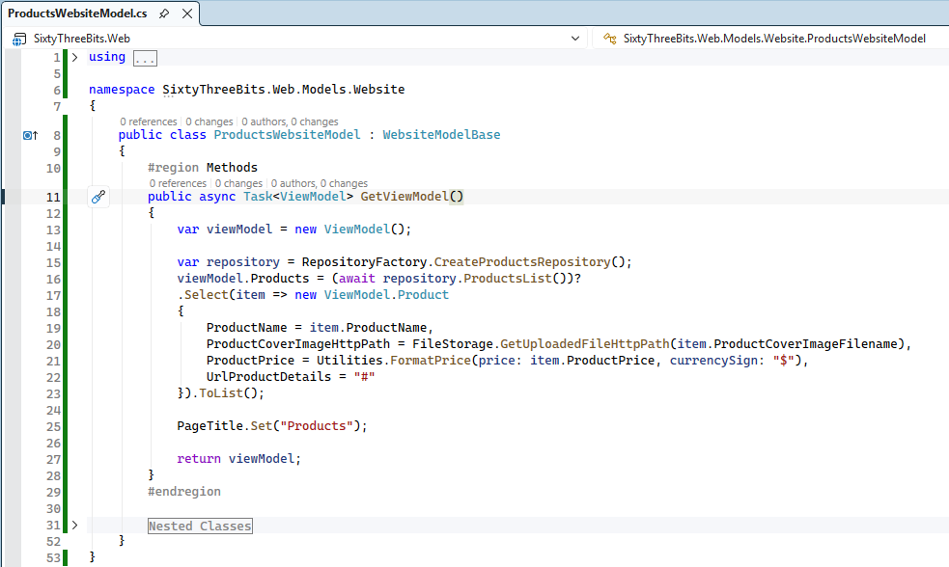

Inherited Base Properties
The following properties are inherited through the inheritance chain: WebsiteModelBase → ModelBase
- RepositoryFactory – Provides access to the factory for creating repository instances.
- Utilities – Offers helper functions such as price formatting (for example, converting numeric values to display format like $99.95).
- FileStorage – Manages file uploads and generates HTTP-accessible paths for uploaded files, which can be used in HTML <img> tags.
- PageTitle – Sets the browser tab title for the page.

Null-Conditional Operator
Pay close attention to the null-conditional operator (?) used in repository method calls:
(await repository.ProductsList())?
The question mark prevents null reference exceptions by safely handling null values during execution.

Controllers
Navigate to SixtyThreeBits.Web → Controllers → Website and create a new directory named Products. This directory organizes all product-related controllers in one location.
Inside the Products directory, create a new file named ProductsWebsiteController.cs.

Implement code according to screenshot below
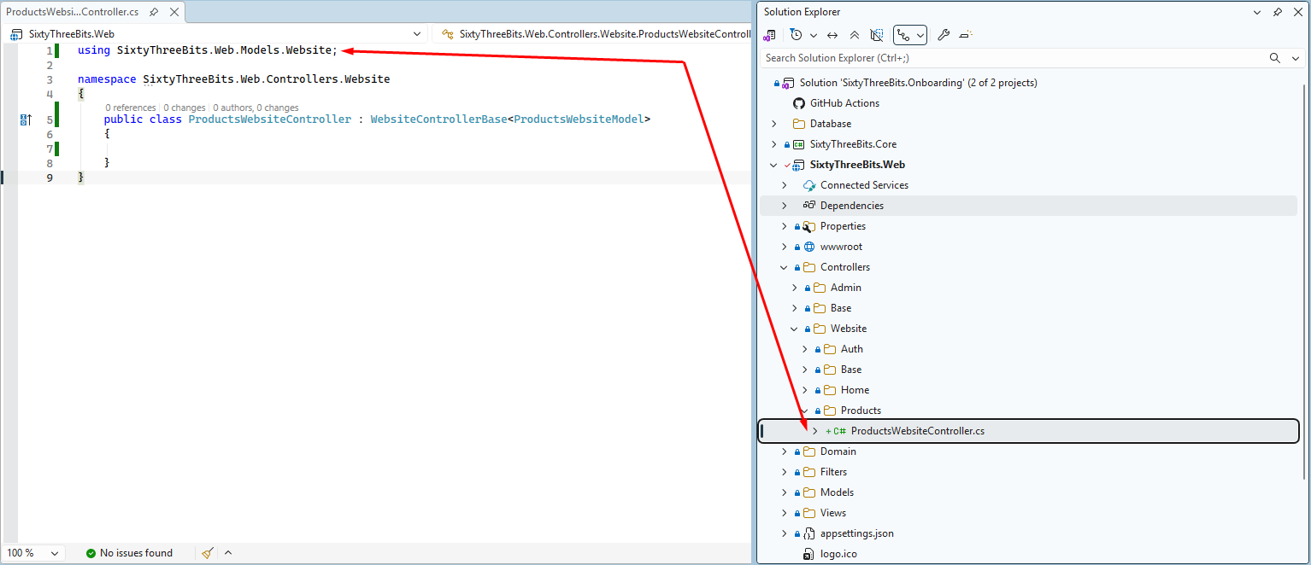

Note that the class name ProductsWebsiteController uses the plural form, indicating that this controller is responsible for handling and presenting multiple products.

Actions

Declare a const string property _viewName in the controller class. This property represents the full path to the view that the controller uses.
Each controller is associated with exactly one view, and each view is associated with exactly one controller.

Implement code according to screenshot below:
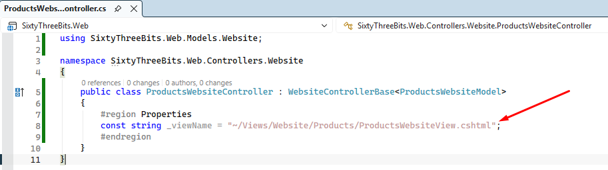

Before implementing actions, review the following resource to understand Attribute Routing, which is essential for proper controller implementation:

https://devblogs.microsoft.com/dotnet/attribute-routing-in-asp-net-mvc-5/

Implement code according to screenshot below:

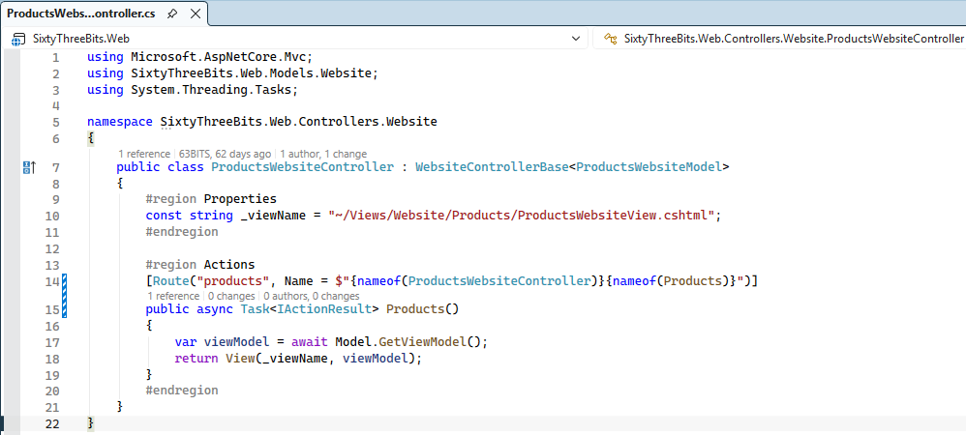

Views
Navigate to SixtyThreeBits.Web → Views → Website and create a new directory named Products. This directory organizes all product-related Views in one location. Inside the Products directory, create a new file named ProductsWebsiteView.cshtml.
Implement code, connect model to your view according to screenshot below.
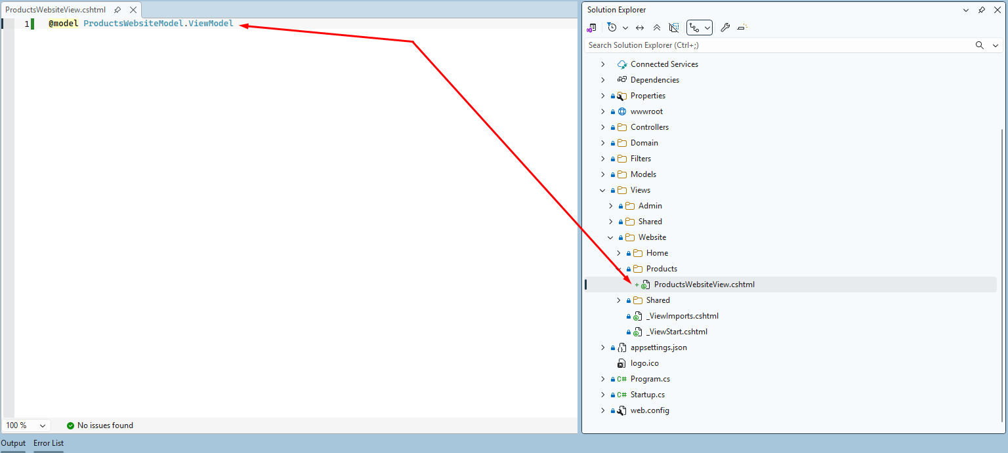

Navigate to SixtyThreeBits.Web → wwwroot → html → products.html
products.html is static HTML file which we will use to for building dynamic cshtml view.

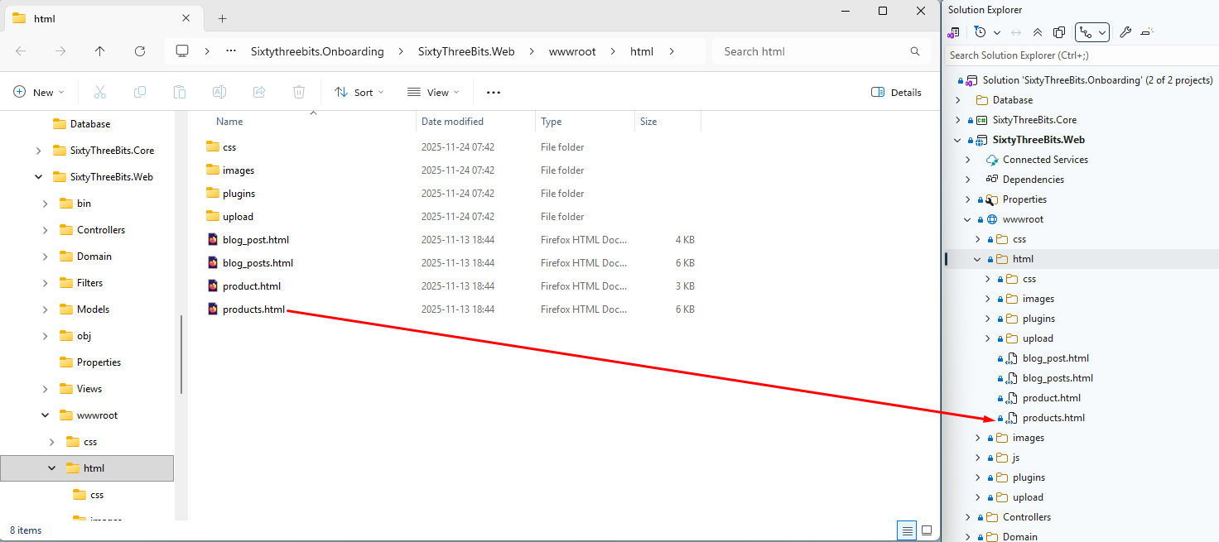

Open products.html using your web browser. This is how your final result must look!

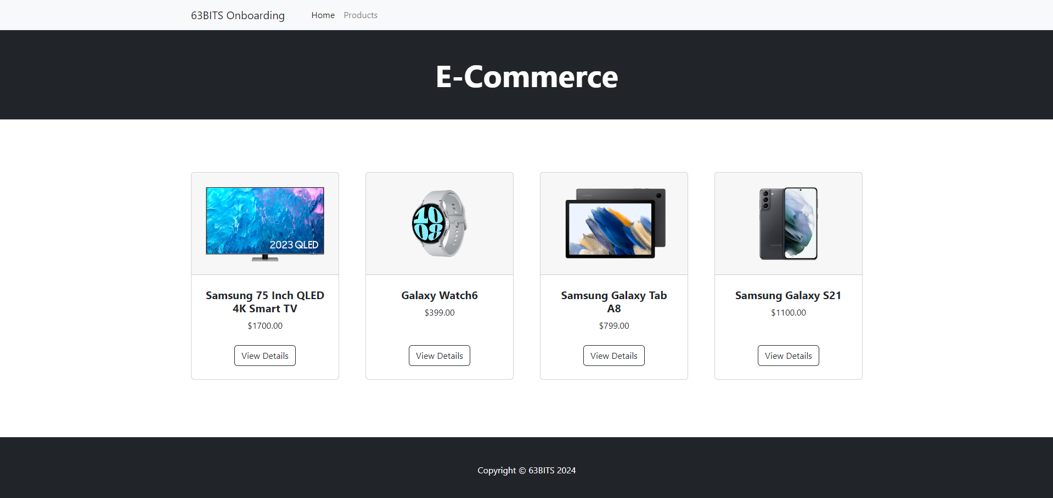

Open products.html file in visual studio, to see HTML code.

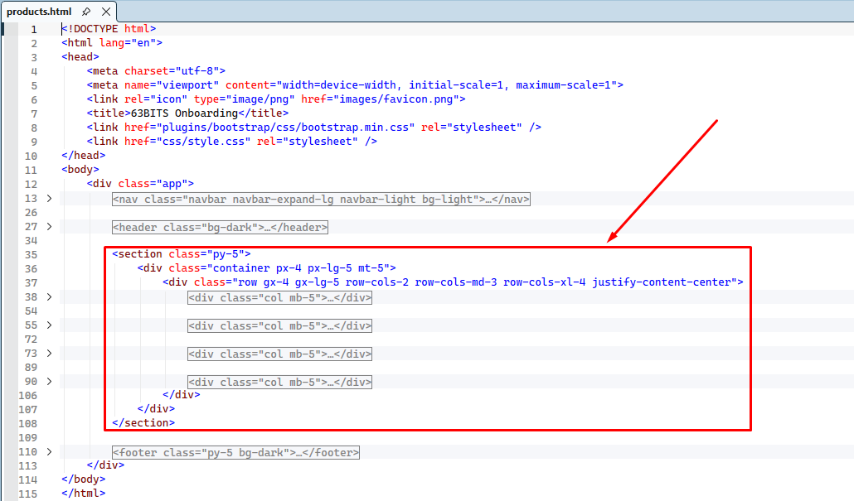

Copy <section> html block and Paste it to your ProductsWebsiteView.cshtml file

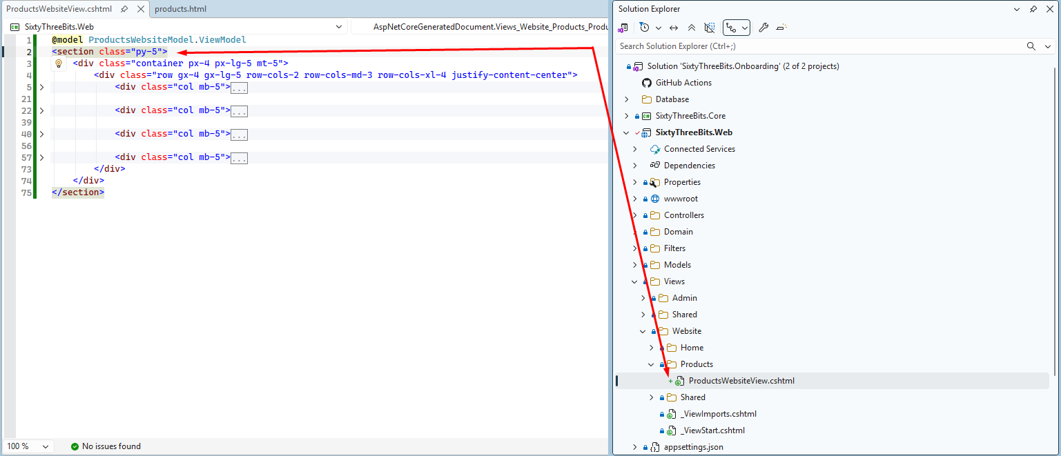

You don’t need to copy <html> <body> <header> <footer> above and below <section> tag, they are already provided in by _Layout.cshtml which wraps all website level views.

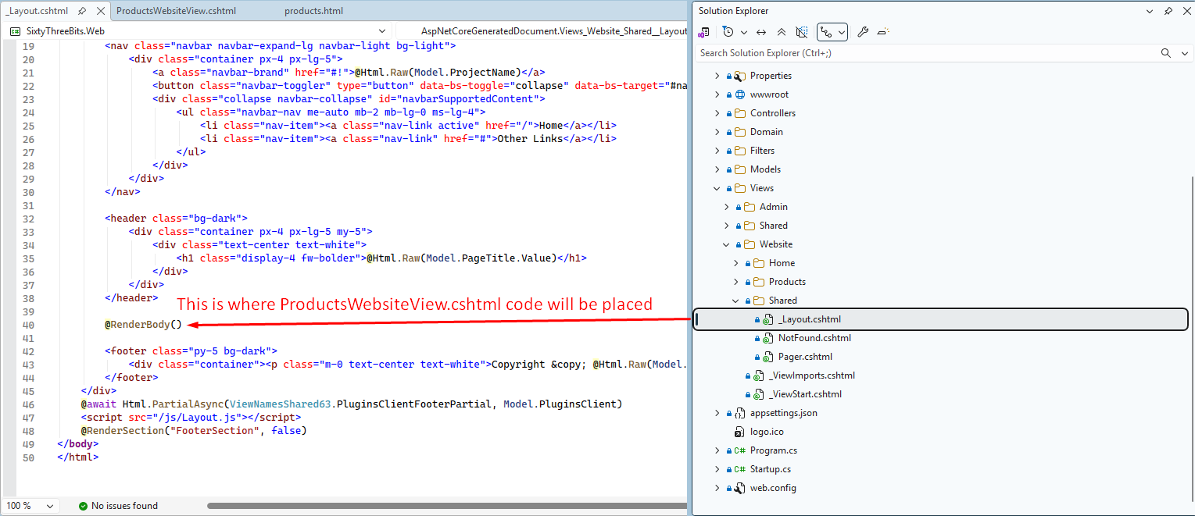

Replace the repeating static HTML <div> blocks with a foreach loop that iterates through the Products collection provided by the controller and model via @model.

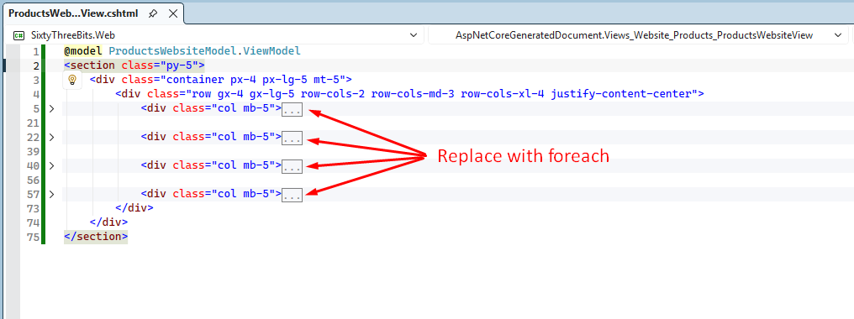

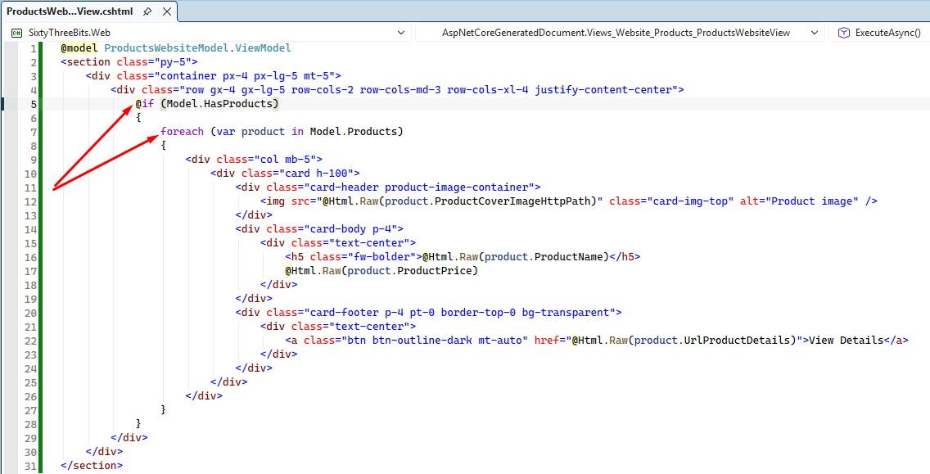

Null Safety Check
The @if (Model.HasProducts) block performs a safety check before executing the foreach loop:
foreach (var product in Model.Products)
This prevents null reference exceptions by verifying the collection contains items before iteration.

HTML Rendering
The @Html.Raw(...) directive is used throughout the view to render HTML content from product properties without escaping.
For detailed information on HTML encoding and the Raw helper, review the following resources:
- https://learn.microsoft.com/en-us/aspnet/core/mvc/views/razor?view=aspnetcore-8.0#expression-encoding
- https://learn.microsoft.com/en-us/dotnet/api/system.web.webpages.html.htmlhelper.raw?view=aspnet-webpages-3.2

Launch

To verify the functionality built so far, first populate the database with sample data.

Use SQL Server Management Studio, manually insert records into the Products and Categories tables.

Next, download appropriate product images from the web and place them in the wwwroot → upload directory. Ensure that the image filenames match the values stored in the ProductCoverImageFilename column.

To run the project, press CTRL + F5. The browser will open automatically, and the home page will load. You should see a page similar to the example shown below.

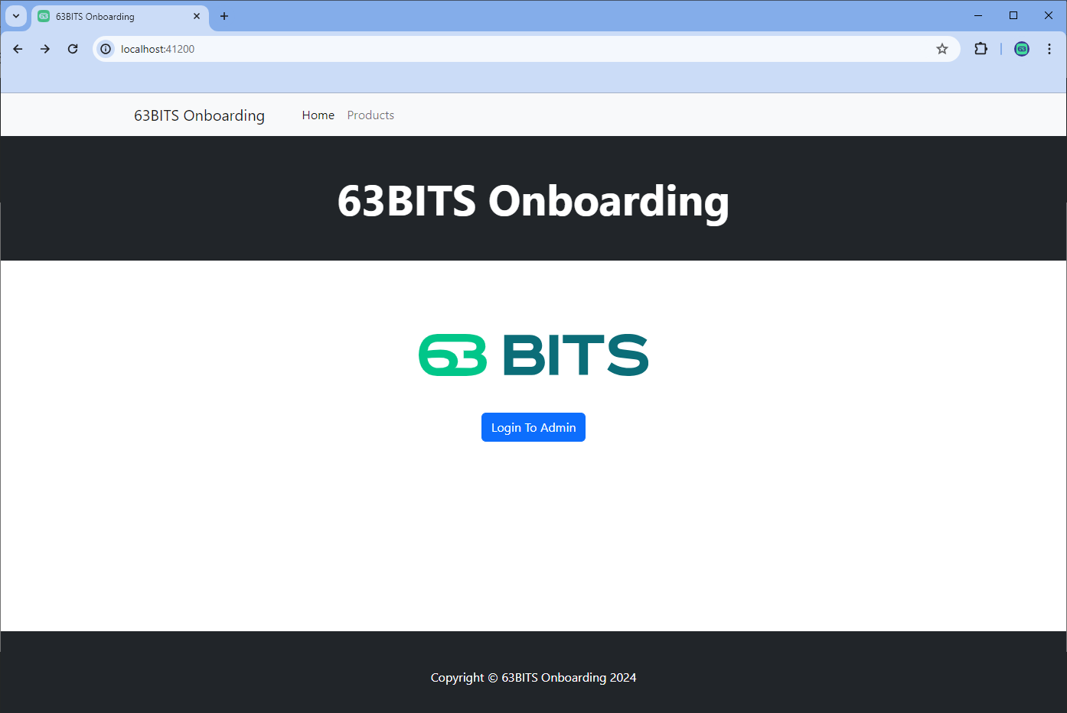

To view the Products page, manually navigate to /products in the browser address bar. The Products page will then load and display the results.

